Binary Search Tree (additional functionalities)

# **Summary:**

This program entails two classes, a **template binary** **search tree class** with this name **BSTFCI** and a **node class** with name **BSTNode.** The following functionalities are provided (Check Tree Balance, Tree Comparison, Print Range and T).

**1. Checking Tree Balance:**A **Balanced Binary Tree** is a tree where the **heights** of the two child sub-trees of any node differ by at most one and the left subtree is balanced, and the right subtree is balanced. The method “**isBalance**” checks if the BST is balanced or not.

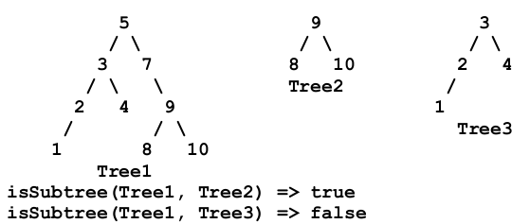**2. Tree Comparison:**A function that decides if a **BSTFCI T2** is a sub-tree of another **BSTFCI T1**.   
Prototype: **bool isSubTree(BSTFCI* t1, BSTFCI* t2);**

**3. Print Range:**A recursive function named “**printRange**” that stores integers given a low key value and a high key value, then prints in sorted order all records whose key values fall between the two given keys by visiting as few nodes in the BST as possible.

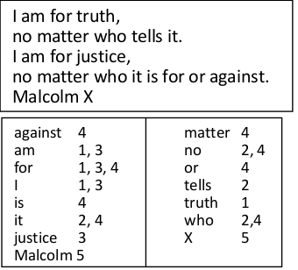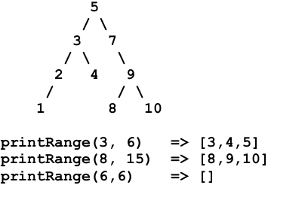**4. Number of Lines of each Word:**This is an app that makes use of our class **BSTFCI,** the application takes text consisting of lines and prints a list of the words of the text and the lines they appear on are printed next to them.   
The application works by building a binary search tree and each node contains a word and a vector of that contains the list of lines where this word exists. The punctuation marks like “.” and “,” are removed before processing the text.

The project is built using **C++, Visual Studio**.